cut command in Linux with examples

- The cut command in linux is a command for cutting out the sections from each line of files and writing the result to standard output.
- It can be used to cut parts of a line by byte position, character, and field.
- The cut command slices a line and extracts the text.
- It is necessary to specify an option with a command otherwise it gives an error.

Syntax of cut Command
The basic syntax of the cut command in Linux is:

cut OPTION... [FILE]..

- `OPTION` defines how the Linux cut command behaves.
- `FILE` is the input file.
- If no file is specified, the cut command Unix reads from standard input (stdin).

Note: If FILE is not specified, `cut` reads from standard input (stdin)

Options Available in cut Command
Here is a list of the most commonly used options with the Linux cut command:
Option | Description
-b, --bytes=LIST | Selects only the bytes specified in LIST (e.g., -b 1- 3,7).
-c, --  characters=LIST | Selects only the characters specified in LIST (e.g., - c 1-3,7).
-d, --  delimiter=DELIM | Uses DELIM as the field delimiter character instead of the tab character.
-f, --fields=LIS | Selects only the fields specified in LIST, separated by the delimiter character (default is tab).
-n | Do not split multi-byte characters (no effect unless  -b or -c is specified).

Examples of cut Command
Let us consider two files having name state.txt and capital.txt contains 5 names of the Indian states and capitals respectively.

$ cat state.txt Andhra Pradesh Arunachal Pradesh Assam
Bihar Chhattisgarh

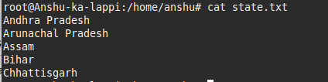
see file content
Running the cut command without an option results in an error:

$ cut state.txt
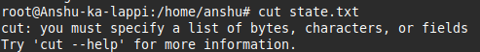
cut command

Extract Specific Bytes ( -b) Using cut Command
- -b( byte) : The -b option in the Linux cut command extracts specific bytes.
- You specify byte numbers separated by commas or a range with a hyphen (-).
- Without a valid byte list, the cut command errors out.
Note: Tabs and backspaces are treated like as a character of 1 byte.

List without ranges:

It will extract and display the 1st, 2nd, and 3rd bytes (characters) from each line of the state.txt file

cut -b 1,2,3 state.txt
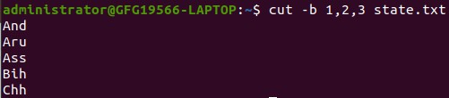
list without range

List with ranges:

It will extract characters from positions 1 to 3, and then from 5 to 7, from each line of the file named state.txt
cut -b 1-3,5-7 state.txt
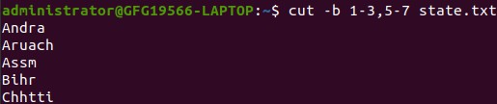
list with range
It uses a special form for selecting bytes from beginning upto the end of the line:

Special Form: Selecting bytes from beginning to end of line

In this, 1- indicate from 1st byte to end byte of a line

cut -b 1- state.txt
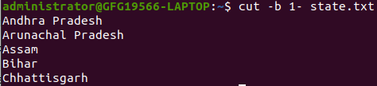
special form with -b option
In this, -3 indicate from 1st byte to 3rd byte of a line

cut -b -3 state.txt
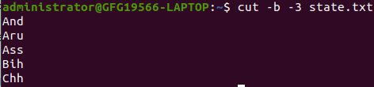
special form -b option

Cut by Character ( -c) Using cut Command
- -c ( column) : The -c option in the cut command Unix extracts characters.
- You can specify a list of character positions with commas or a range with a hyphen (-).
- Tabs and backspaces are treated as single characters, and a valid character list is required to avoid errors.
Syntax:
cut -c [(k)-(n)/(k),(n)/(n)] filename

Here,k denotes the starting position of the character and n denotes the ending position of the character in each line, if k and n are separated by "-" otherwise they are only the position of character in each line from the file taken as an input.

Extract specific characters:

It will extract and display the characters at positions 2, 5, and 7 from each line of the file named state.txt

cut -c 2,5,7 state.txt
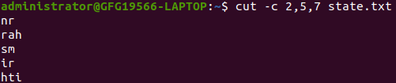
Extract specific characters
This cut in Unix command prints the 2nd, 5th, and 7th characters from each line.

Extract first seven characters:

It extracts and displays the first 7 characters from each line of the file named state.txt.
cut -c 1-7 state.txt
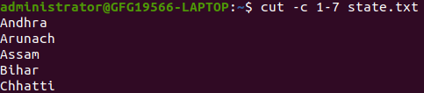

Extract first seven characters
Above cut command prints first seven characters of each line from the file. Cut uses a special form for selecting characters from beginning upto the end of the line:

Special Form: Selecting characters from beginning to end of line
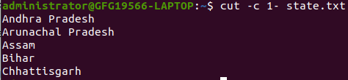
cut -c 1- state.txt
selecting characters from beginning to end of line using -c option
Above command prints starting from first character to end. Here in command only starting position is specified and the ending position is omitted.

cut -c -5 state.txt
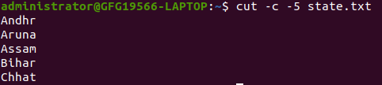
Above command prints starting position to the fifth character. Here the starting position is omitted and the ending position is specified.

Cut by Field ( -f) Using cut Command
- -f ( field) : The -f option in the cut command Linux is ideal for files without fixed-length lines.
- It extracts fields separated by a delimiter (default is tab).
- Use the Linux "cut -d" option to specify a custom delimiter, like a space.
Note: Space is not considered as delimiter in UNIX.

Syntax:

cut -d "delimiter" -f (field number) file.txt

Extract first field :
Like in the file state.txt fields are separated by space if -d option is not used then it prints whole line:
cut -f 1 state.txt
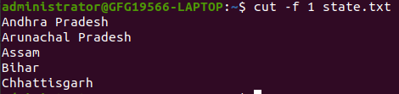
Extract first field using -f option
If `-d` option is used then it considered space as a field separator or delimiter:

cut -d " " -f 1 state.txt
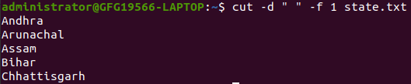
space as a field separator or delimiter

Extract fields 1 to 4:

Command prints field from first to fourth of each line from the file.

cut -d " " -f 1-4 state.txt
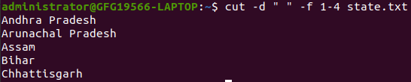
Command prints field from first to fourth

Display Version ( --version) Using cut Command
--version: This option is used to display the version of cut which is currently running on your system.

cut --version

How to use tail with pipes( |) in cut Command
- The cut command can be piped with many other commands.
- In the following example output of the cat command is given as input to the cut command with -f option to sort the state names coming from file state.txt in the reverse order.

cat state.txt | cut -d ' ' -f 1 | sort -r
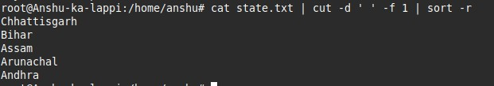
using tail with pipe (|) in cut command
It can also be piped with one or more filters for additional processing.
Like in the following example, we are using cat, head and cut command and whose output is stored in the file name list.txt using directive(>).

cat state.txt | head -n 3 | cut -d ' ' -f 1 > list.txt

cat list.txt
